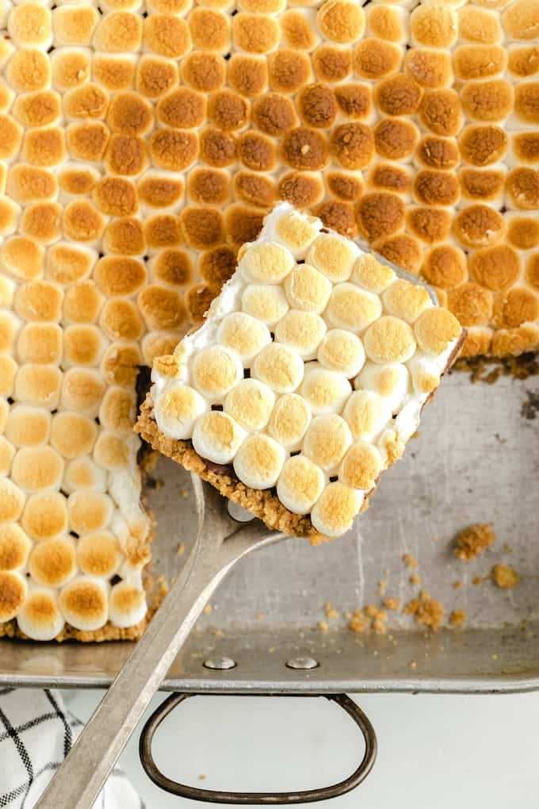
S’mores Bars
Prep time 10 min Cook time 15 min
4 Servings
Ingredients
½ cup graham cracker crumbs
3 tbsp butter
½ cup powdered sugar
4.4 oz Hershey Chocolate Bar
¼ package mini marshmallows
Directions
- Preheat oven to 350 degrees.
- Grease 4 x 8 loaf pan with non-stick butter spray.
- In a medium size bowl, melt the butter and mix with graham cracker crumbs and powdered sugar.
- Place mixture in the bottom of the baking pan. Distribute the mixture evenly and press down and firmly with your fingers to "pack it" along the bottom and sides of the pan.
- Place in oven and bake for approx. 5-8 minutes (just until sides begin to get a bit golden brown).
- Lay the Hershey bars on top of the graham cracker mixture covering the graham crackers.
- Place in over for approximately 3 minutes (until chocolate just begins to melt and gets shiny).
- Place marshmallows on top of the chocolate - pack them in there closely next to each other.
- Turn oven to "broil" - put pan into oven and STARE at them! They only need to be in there for about 2 minutes. Every oven is different! Watch them like a hawk or they will burn and set on fire. As soon as they begin to brown, take them out of the oven.
- Let them cool completely. After they initially cooled, you can place them in the refrigerator to set even more. This will make them easier to cut.
- Cut and serve. You can run a knife under hot water and wipe dry in order to cut them easier.

